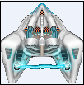
Worksheet 2 - Asteroid Shoot-em Up
Aims: To program the ship to shoot bullets.
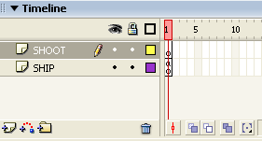
- Load up your Asteroids game.

- Start by creating a new layer and rename it shoot

- Click on the Actions bar in the properties to make it visible so we can enter the following code to make the ship shoot bullets
var bulletSpeed = 9;
var bulletReady = true;
var bulletDelay = 150;
var bulletArray = [];
var bulletCount = 0;

function createBullets(){
var bulletMc = this.attachMovie("bullet1", "bullet1"+bulletCount, 1000+bulletCount);
bulletCount++;
bulletMc._x = shipMc._x+(shipMc._width/2)-(bulletMc._width/2);
bulletMc._y = shipMc._y+bulletMc._height;
bulletArray.push(bulletMc);
}
function moveBullets(){
if(bulletReady && Key.isDown(Key.SPACE)){
trace(bulletArray.length);
bulletReady = false;
currentTime = getTimer();
createBullets();
} else {
if(currentTime+bulletDelay<=getTimer()){
bulletReady = true
}
}
for(var i = 0; i<bulletArray.length; i++){
bulletArray[i]._y -=bulletSpeed
}
}
this.onEnterFrame = function(){
moveShip();
moveBullets();
};

4. You will need to go back to Ship code and delete the last section of code as we are not working from this frame.
Remove from the ship code…
this.onEnterFrame = function(){
moveShip();
};

- Go to Control and Test Scene to see if the ship moves from left to right and up and down and now fires bullets.

